The idea was to sharpen the triangular waveform within the appropriate frequency range, which is the frequency of a dog’s breath.

The shape of the filter was given in the following graph.

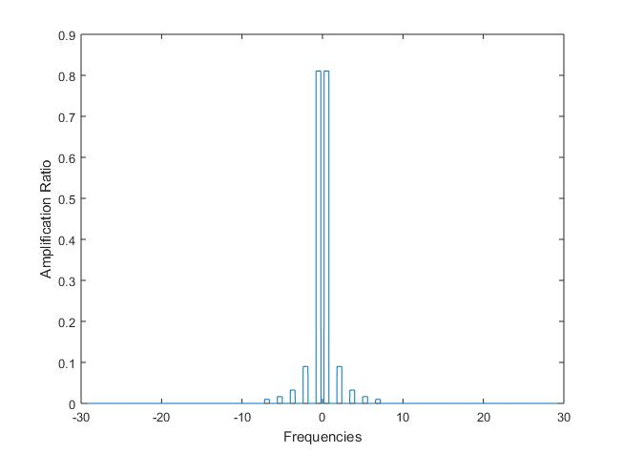

All lobes of filter are rectangular shaped with fixed width. The main lobe which is circled in red were used to capture the signal within dog breathing frequency range. The side lobes which is circled in blue was used to preserve the triangular shape of the wave form.

The expression of the filter is shown as follows:

$$filter = \sum_{1}^{n}{4\frac{1-{(-1)}^{n}}{π^{2}n^{2}}}f(x) x∈[n0.8-0.6, n0.8]$$

In this equation f(x) is the signal frequency spectrum, 0.8 is the upper bound frequency of the main lobe, 0.6 is the window width, n is the number of harmonic.